Answers
1. An algorithm has been created which allows users to enter a number.
The number is added to a total. The user is then asked if they want to add another item. If they enter ‘Yes’ then they are asked to enter another number. If they enter ‘No’ the total is output and the program ends.
The following flowchart for the algorithm has been created.
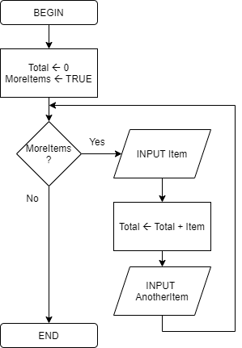
(a) The flowchart does not correctly implement the algorithm. Amend the flowchart to correctly reflect the scenario given. [8]
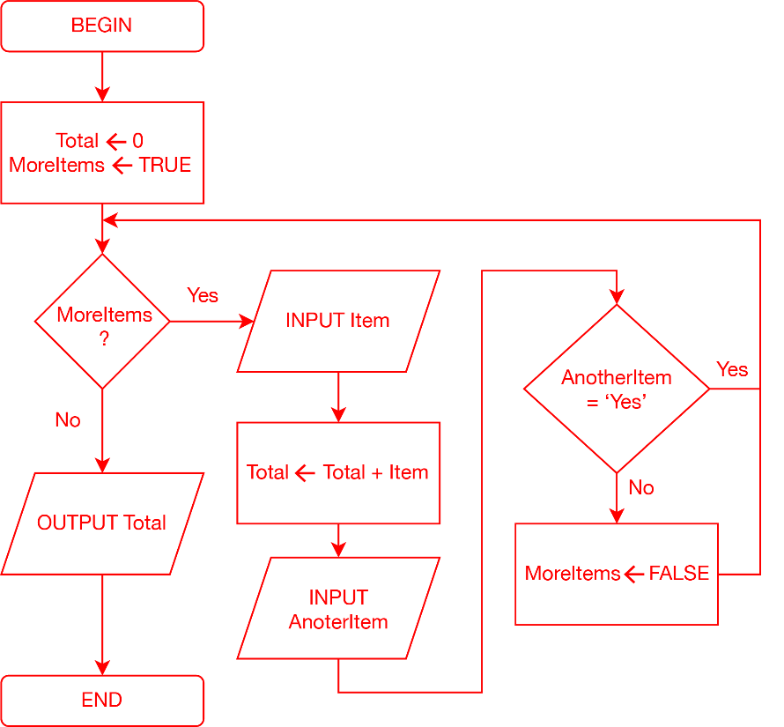
Decision when AnotherItem = ‘Yes’ (1)
Use of a decision symbol (1)
MoreItems False (1)
Use of a process box (1)
Correct Yes/No labels (1)
Correct arrows (1)
Output Total (1)
Output symbol (1)
Accept alternative solutions that implement the algorithm correctly.
(b) Rewrite the algorithm using pseudocode. [4]
Total 0
MoreItems TRUE
IF MoreItems
THEN
INPUT Item
Total Total + Item
INPUT AnotherItem
IF AnotherItem <> "Yes"
THEN
MoreItems FALSE
ENDIF
ENDIF
OUTPUT Total
Use of IF statement (1)
Correct use of nested IF statement with Boolean expression (1)
Assignment of Total, MoreItems and Total Total + Item (1)
Correct use of INPUT and OUTPUT statements (1)
Accept alternatives that correctly implement the scenario given.
[Total 12 marks]

